# A

**PROJECT REPORT ON**

# Infra-Bazaar

**(An e-commerce platform)**

SUBMITTED IN PARTIAL FULFILLMENT OF

# DIPLOMA IN ADVANCED COMPUTING (PG-DAC)



**UNDER THE GUIDANCE OF**

# Ms. Prajakta Patil

**PRESENTED BY**

|  |  |
| --- | --- |
| **220330920022** | **Kiran Namdev Mahanor.** |
| **220330920026** | **Mayur Sharad Warke.** |
| **220330920025** | **Mayur Chandrakant Chougule.** |
| **220330920014** | **Devansh Shrivastava.** |
| **220330920007** | **Arshadail Ayub Mulla.** |
|  |  |

# AT

**CENTRE FOR DEVELOPMENT OF ADVANCED COMPUTING (C-DAC), NETCOM,JAIPUR.**

# ACKNOWLEDGEMENT

This project “**Infra-Bazaar**” was a great learning experience for me and I am submitting this work to Advanced Computing Training School (CDAC NETCOM JAIPUR).

I am very glad to mention the name of *Ms. Prajakta Patil* for his valuable guidance to work on this project. His guidance and support helped me to overcome various obstacles and intricacies during the course of the project work.

I am highly grateful to *Ms. Rekha Sharma*. (Manager (ACTS training Centre), C- DAC, for her guidance and support whenever necessary while doing this course *Online Diploma in Advanced Computing (PG-DAC)* through C-DAC Netcom, Jaipur.

My heartfelt thanks go to *Ms. Suchita Manak Bohra.* (Course Coordinator, PG-*DAC*) who gave all the required support and kind coordination to provide all the necessities like required hardware, internet facility, and extra Lab hours to complete the project and throughout the course up to the last day here in C-DAC Netcom, Jaipur.

# From:

# Kiran Namdev Mahanor. (220330920022)

# Mayur Sharad Warke. (220330920026)

# Mayur Chandrakant Chougule. (220330920025)

# Devansh Shrivastava. (220330920014)

# Arshadali Ayub Mulla. (220330920007)

**(Name) (Name)**

**Supervisor/Guide Faculty**

## ABSTRACT

The Infra Bazaar system permits a customer to place online orders for items and/or services from a store that serves both walk-in customers and online customers. The Infra Bazaar system presents an online display of an order cut off time and an associated delivery window for items selected by the customer. The system accepts the customer's submission of a purchase order for the item in response to a time of submission being before the order cut off time. The Infra Bazaar system does not settle with a credit supplier of the customer until the item selected by the customer is picked from inventory but before it is delivered. Therefore, the customer can go online and make changes to the order.

In addition, available service windows are presented to the customer as a function of customer selected order and service types and further, the order picking is assigned in accordance with a picker's preference. When ordering goods, many shopping systems provide a virtual shopping cart for holding items selected for purchase. Successive items selected for purchase are placed into the virtual shopping cart until a customer completes their shopping trip. Virtual shopping carts may be examined at any time, and their contents can be edited or deleted at the option of the customer. Once the customer decides to submit a purchase order, the customer may print the contents of the virtual shopping basket in order to obtain a hard copy record of the transaction.

## Contents

|  |  |
| --- | --- |
| **Chapter** | **Contents** |
| **1** | **INTRODUCTION:** |
|  | **1.1 Description** |
|  | **1.2 Problem Formulation** |
|  | **1.3 Motivation** |
|  | **1.3 Proposed Solution:** |
|  | **1.4 Scope of the project** |
| **2** | **REVIEW OF LITERATURE** |
| **3** | **SYSTEM ANALYSIS** |

|  |  |  |  |
| --- | --- | --- | --- |
|  |  | **3.1 Functional Requirements** |  |
|  | **3.2 Non-Functional Requirements** |
|  | **3.3 Specific Requirements** |
|  | **Software Development Process Model** |
| **4** | **ANALYSIS MODELING** |
|  | * 1. **Use-Case Diagrams and description**   2. **Activity Diagrams**   3. **Class Diagram**   4. **Sequence Diagram**   5. **Data Flow Diagram** |
| 5 | **Database Tables** |
| **7** | **DESIGN** |
|  | **5.1 Data Modeling *(E-R Model, Relational tables with its associated Data dictionary****)* ER Diagram normalized till the third normal form accompanied by the respective data dictionary table should be included |
|  | **Architectural Design** |
| 8 | **User Interface Design** GUI for your project |
| **9** | **Conclusion** |
| 10 | **Acknowledgement** |
|  | | | |

|  |  |
| --- | --- |
| **Fig. No.** | **Figure Caption** |
| 1 | Use Case Diagram |
| 2 | Class Diagram |
| 3 | Activity Diagram for   1. Admin 2. Manager 3. User |
| 4 | Sequence Diagram for   1. Admin 2. Manager 3. User |
| 5 | Data Flow Diagram |

**Chapter 1 Introduction**

Customer get many benefits via online shopping this helps e-commerce companies to build long- lasting and profitable relationship with their customers. For making strong relationship with these users, it is very important to focus on the customer as a whole and making sense of a flood of real-time information that goes well beyond demo graphics or shopping behavior. There are two entities who will have the access to the system. One is the admin and another one will be the registered user.

Admin can add product details, view all the order details and can also view the sales of the products. User need to register with basic registration details to generate a valid username and password. After the user logins, it can view all the products that are recommended on the homepage compiled by the system based on user’s information. From the recommended products, the user caneven further view its details and then if interested to buy, the system gives add to cart option for purchasing the product.

## Description:

This project is a web application for online platform for seller as well as buyer to sell infrastructure material in which Admin is able to register a user as well as do complete monitoring of application. Admin can manage category of product as well as manage product, that is admin can update, delete, add product category after this he is able to add variety of infrastructure product inside the categories created by him. Admin is also able to add another Admin and Manager followed by this he can also able to see user/manager/admin list along with their primary data.

Manager is second handler of this application able to manage only product category and product likewise admin he is also able to do same task of managing product. User may get registered by admin or he can register himself. User can view product accordingly the categories of product and can explore to various brands and companies product. User is able to add the product which he wanted to buy in the cart that to with quantities. User can buy this product with accurate address and credentials of user, once he done with basic formalities his order is placed by with confirmation mail including order details.

The project 'Infra Bazaar' is based on the database, object-oriented programming and networking techniques. As there are many areas where we keep the records in database for which we are using MY SQL software which is one of the best and the easiest software to keep our information. This project uses Thymeleaf with Bootstrap as the front-end software and has connectivity with MY SQL.

## Problem Formulation:

The idea behind this project is to provide online platform for customer as well as seller to sell the infrastructure materials so we are going to provide this platform for connecting customer as with seller. Due to COVID pandemic situation small shop business almost stopped and using this website small scale business will grow and our ultimate goal is provide best solution dynamic website for easy selling and buying.

We have tried our best to make the complicated process of Infrastructure materials selling and buying as simple as possible using Structured & Modular technique & Menu oriented interface. We have tried to design the software in such a way that the user may not have any difficulty in using this package & further expansion is possible without much effort. Even though we cannot claim that this work to be entirely exhaustive, the main purpose of our exercise is to perform each activity in online way rather than manually which is time consuming.

## Motivation:

### Wide Variety of Materials:

Offline construction materials store usually have a limited variety of products in their stock, owing to warehousing and storage space scarcity. Some may stock cement while others may stock steel, necessitating multiple visits to the market to find everything that is needed. Online stores do not have the constraints of physical space.

They can story endless categories of products, complete with information and pricing so that all requirements can be found in a single place. In addition, you can access a wide variety of materials, manufacturers and suppliers on a single platform. This arrangement offers easy and convenient price discovery, in addition to letting you compare various products. Overall, these features save much time and expedites project timelines.

### Quality Assurance:

The quality of unbranded materials such as sand, bricks and aggregate is difficult to determine. For this reason, many offline shops that stock poor quality materials can get away with an unscathed reputation. However, platforms selling construction materials online associate with certified suppliers, so as to safeguard their reputation. This ensures quality-tested products for the purchaser.

### Greater Convenience:

The convenience of purchasing construction materials online is unparalleled. Purchasers can browse the complete inventory at their fingertips. Online retailers also have efficient delivery teams that bring products and even samples to the consumers’ doorsteps. Online platforms also help streamline the construction project’s life-cycle by offering processes such as price discovery, raising RFQs, instant purchase, approvals management, order management.

### Better Pricing and Discounts:

Since online portals source materials in bulk, directly from the manufacturer or supplier, they are able to offer handsome discounts and prices for building materials. Buyers can get 35-70% discounts depending on the quality purchased.

Online websites also offer multiple payment options including Net Banking, debit/credit cards and cash on delivery. Some will also give the option of buying on credit.

### Transparent transactions and faster TATs:

Automation has vastly expedited the time required to issue purchase orders online, and in turn, has substantially reduced the back-and-forth between the buyer and retailers. Thus, the turnaround time to complete orders is much shorter when purchases are made online.

At the same time, buyers are able to track the status of their orders in real time. Another important benefit of buying construction materials online is the transparency it ensures in the entire procurement cycle. This is because all processes are regulated through various audits and quality checks.

### Reverse Auction:

The reverse auction is a unique benefit of purchasing construction materials online. Once a purchase request is sent to an online retailer, the retailer then sends it to multiple suppliers. The suppliers bid competitively to secure the sale. This is called reverse auctioning.

The outcome is especially favorable for the end consumer because the final costs are highly competitive. Additionally, online platforms sometimes allow further negotiations directly with the supplier.

# Future Scope

* + Most of the websites that sell Building Materials Online work as a marketplace. These websites either aggregate suppliers, who supply the material, or aggregate manufacturers.
  + The idea behind this project is to provide online platform for customer as well as seller to sell the infrastructure materials like screw, steel, wires, cement, clay etc. so we are going to provide this platform for connecting customer as with seller.
  + Due to COVID pandemic situation small shop business almost stopped and using this website small scale business will grow and our ultimate goal is providing best solution dynamic website for easy selling and buying.

**Chapter 2**

# Review of Literature

As we all know, internet and e-commerce are entirely committed towards every developed country. But we think it can be accomplished and can make a remarkable benefit to developing countries also if an ideal business purpose can be made.

E-commerce is a revolution & turning point in online business practices and can make a huge contribution to the economy, e-commerce organizations have increasingly become a fundamental component of business strategy and a strong catalyst for economic development. A huge amount of research works has been done on e-Commerce which is basically on online shopping. A large group of researchers has found out

and also pointed out the necessity and possibilities of Online Shopping. On the other hand, limitation of e commerce is found and at the same time, they provided essential suggestion and came to a prediction to make.

Online Shopping more useful for the consumers. But the contribution of traditional marketing is also inescapable but compare to online shopping it is less effective.

Though most of the people of our country especially the rural people are not enough capable of operating internet to run the online business. For that reason, they need to be dependent on traditional marketing.

## Chapter 3 System Analysis

### Functional Requirements:

* + 1. **Login of Admin:**
    - The system will allow the admin to manage product category and products.
    - The system will allow the admin to add admin/manager/user.
    - The system will allow the admin to fetch user/manager/admin list.

### Login of Manager:

* + - The system will allow the Manager to manage product category and products.
    - The system will allow the Manager to see all product list and can made changes in management of product.

### Login of User:

* + - The system will allow the User to register themselves.
    - The system will allow the User to view Products.
    - The system will allow the User to view description of product.
    - The system will allow the User to add product in the cart and buy the product.
    - The system will allow the User to see order details.
  1. **Non-functional Requirements:**

### Performance Requirements:

The system should store all the database records of each user, manager and admin staff properly and the application should be available for use 24*7 through the server. Also, the application should be user friendly with a proper user interface which makes it easy for the user to understand. All the options should be present in properly accessible places for user convenience.

Admin staff personnel should be properly trained to operate the application so provided. Product prescriptions, product details, order details, feedback details, records are to be backed up securely across database servers. In case database is hacked by someone and data is deleted a backup server should be present for such purpose.

All login ids and passwords of the admin should be protected for privacy using whatever constraints required in the database or the application.

* + 1. **Safety Requirements:**

All login ids and passwords of the Admin, Manager, and User should be protected for privacy using whatever constraints required in the database or the application. The system requires the individual to acknowledge the person making use of the phone.

Any adjustments like insert, erase, update, etc. for the data source can be integrated promptly as well as executed only by the Admin and Manager. The Admin can consider as well as alter any kind of information in the Infra Bazaar System.

### Security Requirements:

Passwords of the Admin, Manager, and User should be protected for privacy using whatever constraints required in the database or the application. Only admin and Manager will have access rights to the all the data according to the need for E.g.: -User details, passwords etc. The system shall protect the data and service from unauthorized access. The system shall also provide authentication and secure transaction.

### Availability:

The system should run on a variety of operating systems that support the JavaScript language. The system should run on a variety of hardware.

### Accessibility:

The software will be accessible to Admin, Management, and User.

### Compatibility:

The software will be compatible with multiple platforms.

### Durability:

The software will be tested for working with multiple users and records as system has to manage multiple users (Admin, Manager and User) and records (User details, Products categories, Products).

### Effectiveness:

The software will be made to handle operations effectively. The system should provide good quality and be error free.

### Maintainability:

The system should be easy to maintain. There should be a clear separation between the interface and the business logic code. There should be a clear separation between the data access objects that map the database and the business logic code.

**Software Development Process Model**

The meaning of Agile is swift or versatile. **“Agile process model**" refers to a software development approach based on iterative development. Agile methods break tasks into smaller iterations, or parts do not directly involve long term planning. The project scope and requirements are laid down at the beginning of the development process. Plans regarding the number of iterations, the duration and the scope of each iteration are clearly defined in advance.

Each iteration is considered as a short time "frame" in the Agile process model, which typically lasts from one to four weeks. The division of the entire project into smaller parts helps to minimize the project risk and to reduce the overall project delivery time requirements. Each iteration involves a team working through a full software development life cycle including planning, requirements analysis, design, coding, and testing before a working product is demonstrated to the client.

Following are the phases in the Agile model are as follows:

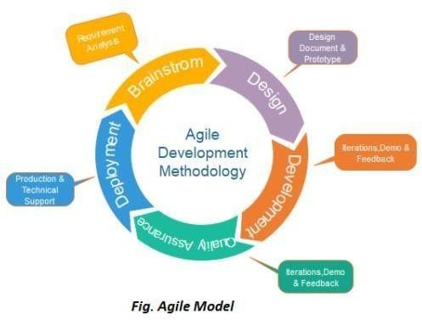

* + - * 1. **Requirements gathering:** In this phase, you must define the requirements. You should explain business opportunities and plan the time and effort needed to build the project. Based on this information, you can evaluate technical and economic feasibility.
        2. **Design the requirements:** When you have identified the project, work with stakeholders to define requirements. You can use the user flow diagram or the high-level UML diagram to show the work of new features and show how it will apply to your existing system.
        3. **Construction/ iteration:** When the team defines the requirements, the work begins. Designers and developers start working on their project, which aims to deploy a working product. The product will undergo various stages of improvement, so it includes simple, minimal functionality.
        4. **Testing:** In this phase, the Quality Assurance team examines the product’s performance and looks for the bug.
        5. **Deployment:** In this phase, the team issues a product for the user's work environment.
        6. **Feedback:** After releasing the product, the last step is feedback. In this, the team receives feedback about the product and works through the feedback.

## Chapter 4 Analysis Modeling

**Use Case Diagram: -**

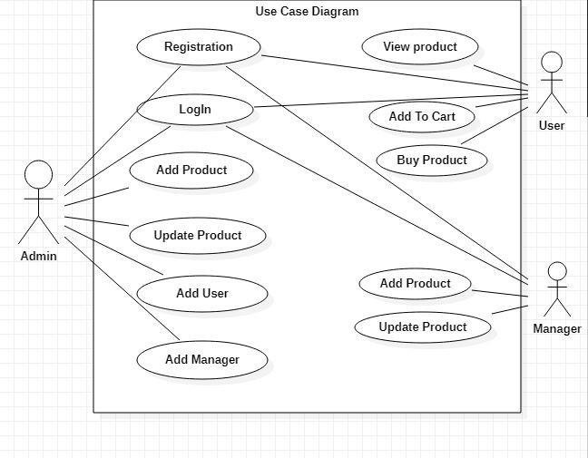

## Class Diagram: -

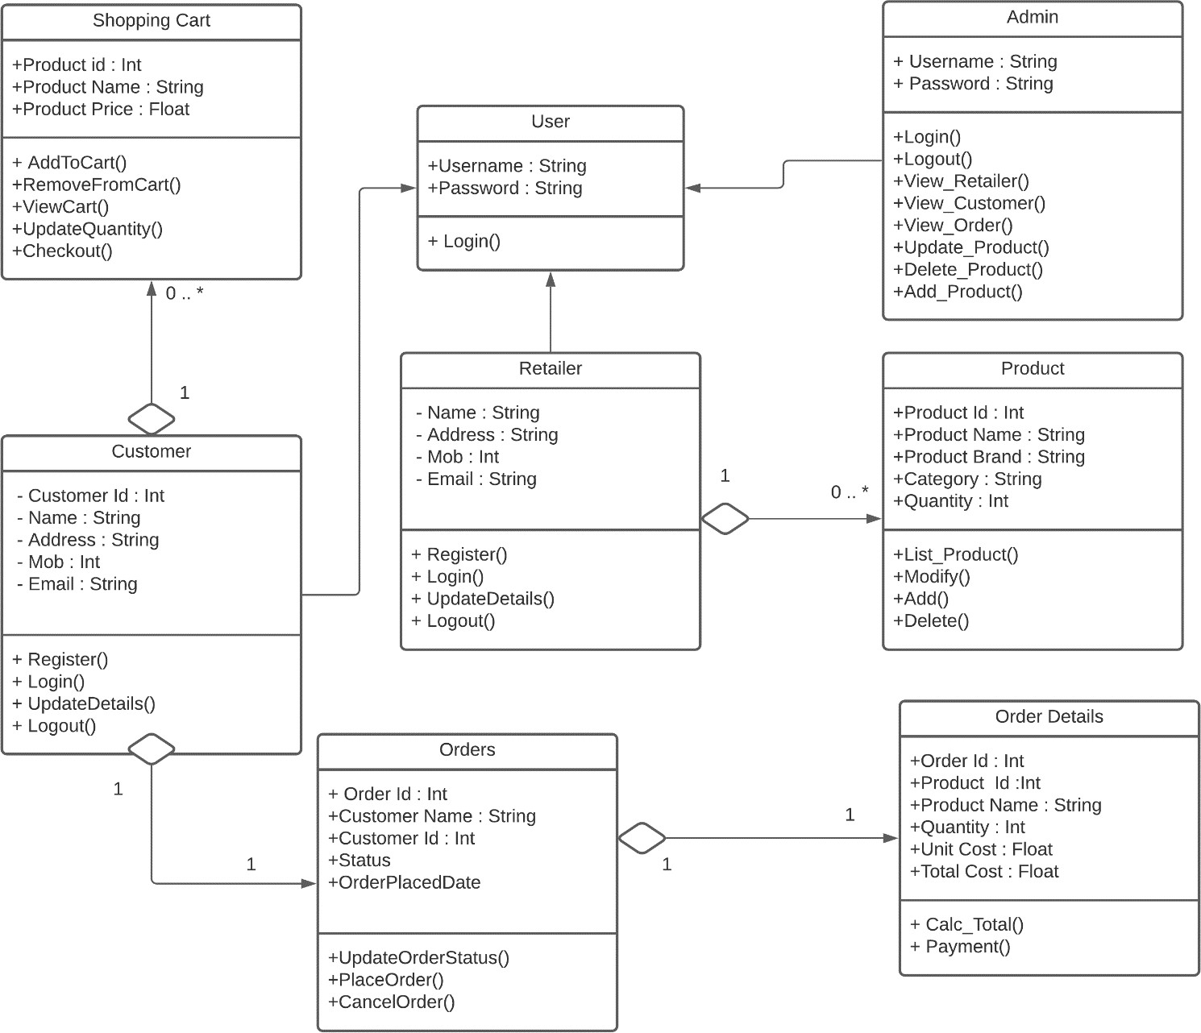

* + **Activity Diagram:**

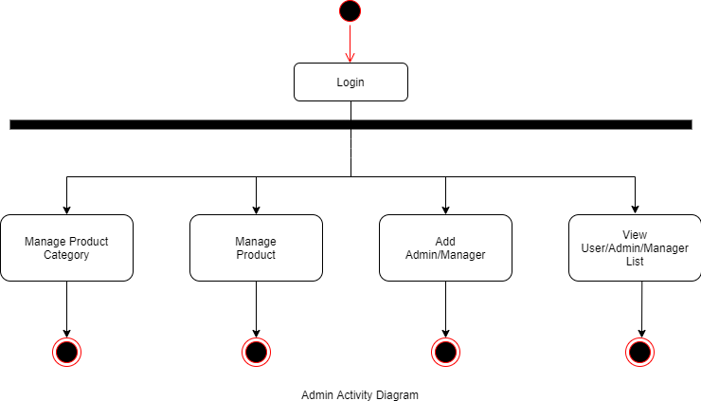

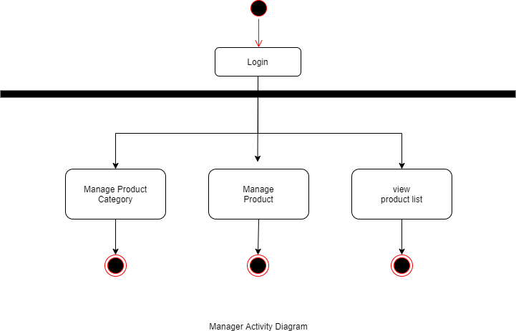

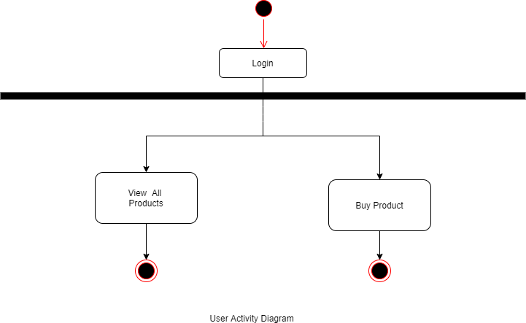

* **Sequence Diagram: -**

### 4.3.1 Users buy products and get confirmation:

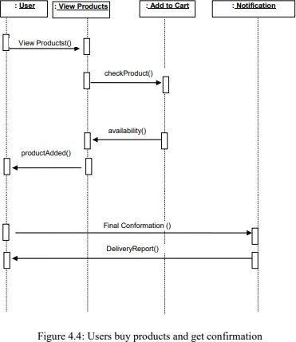

**4.3.2. Admins Add product and category:**

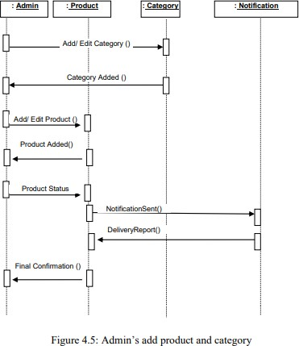

* + 1. **Sequence diagram for product shopping:**

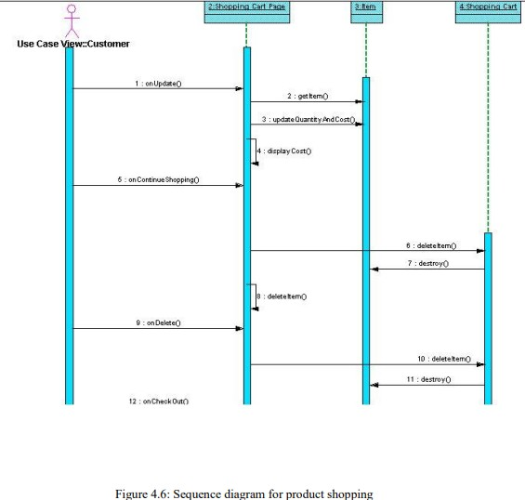

* + - * **Entity-Relationship Model:**



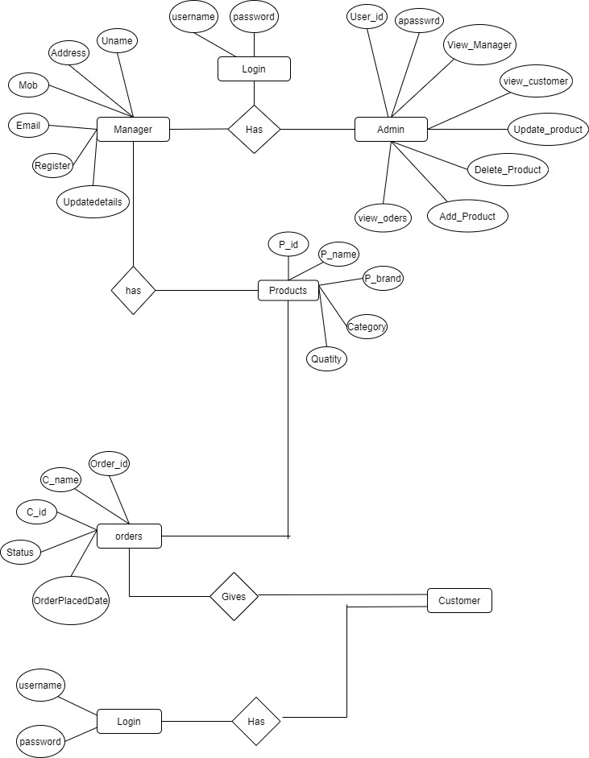



* 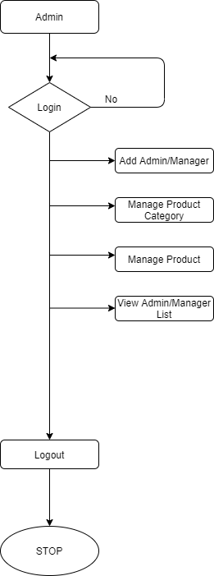**Data Flow Diagram: Admin:**

**Manager:**

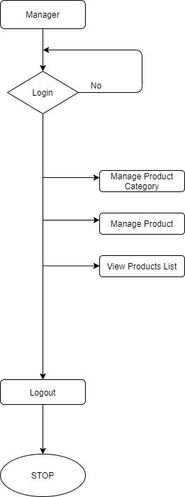

**User:**

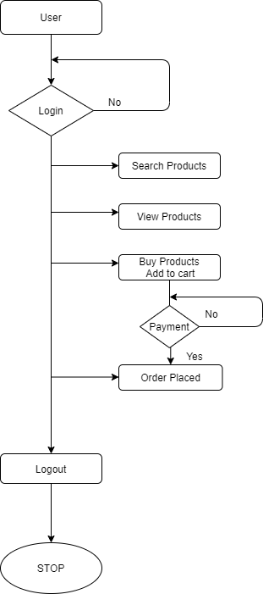

## Database Tables

### User Database Table:

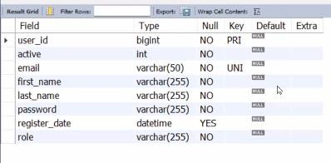

* **Product database:**

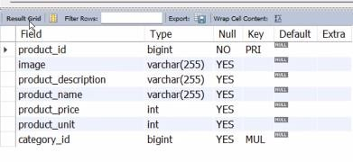

### Categories Database:

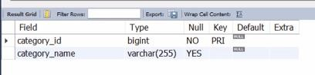

* **Checkout Database:**

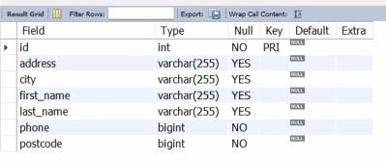

* **Payment Gateway:**

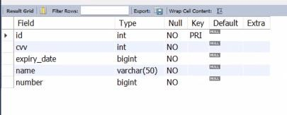

## Chapter 5 DESIGN

**Architecture Diagram:**

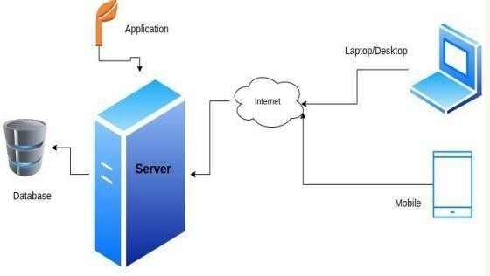

## User Interface:

* + **Home page:**

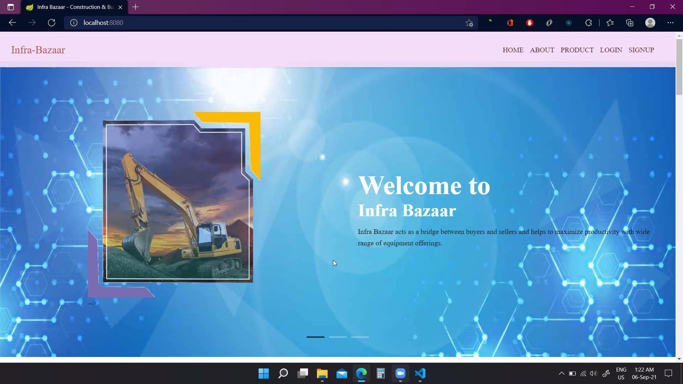

## Home Page Categories:

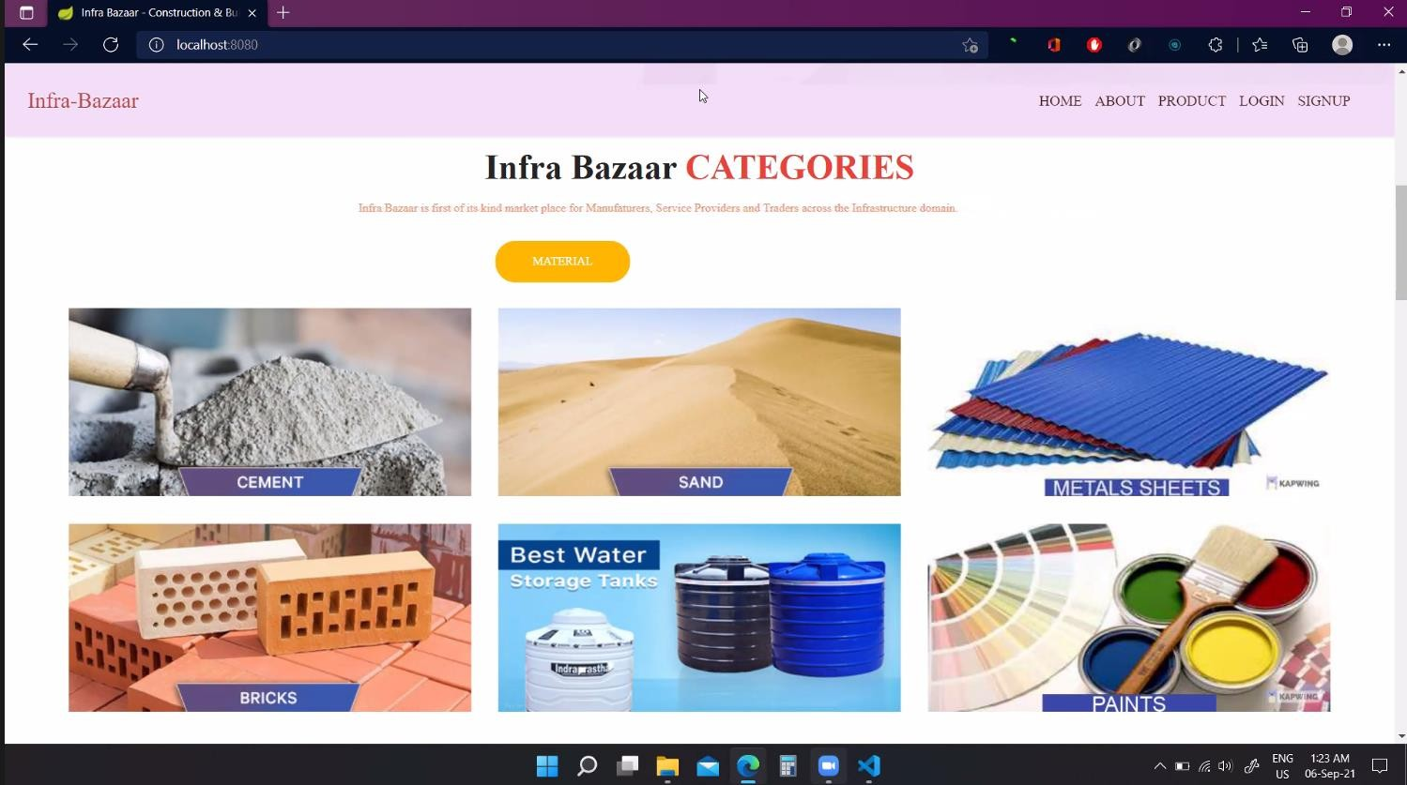

* + **Home Page (Other Features):**

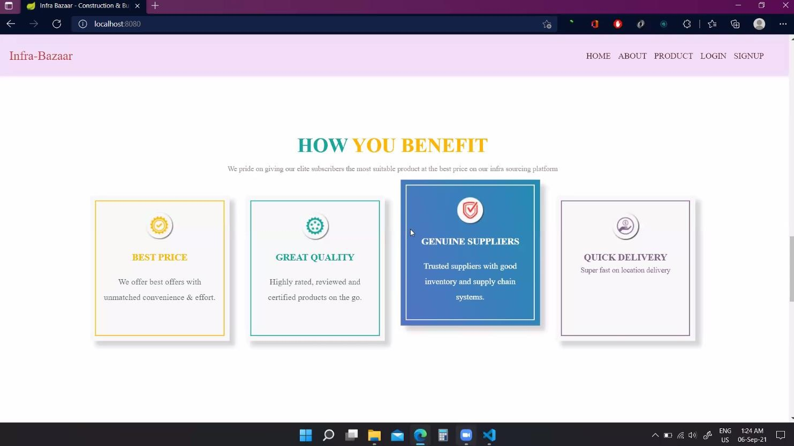

## Home Page (Brands):

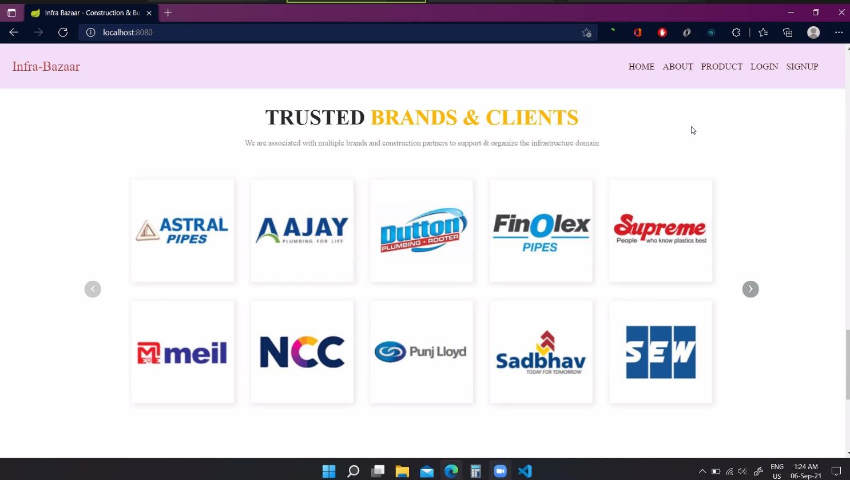

* + **Home Page (Footer and Contact us):**

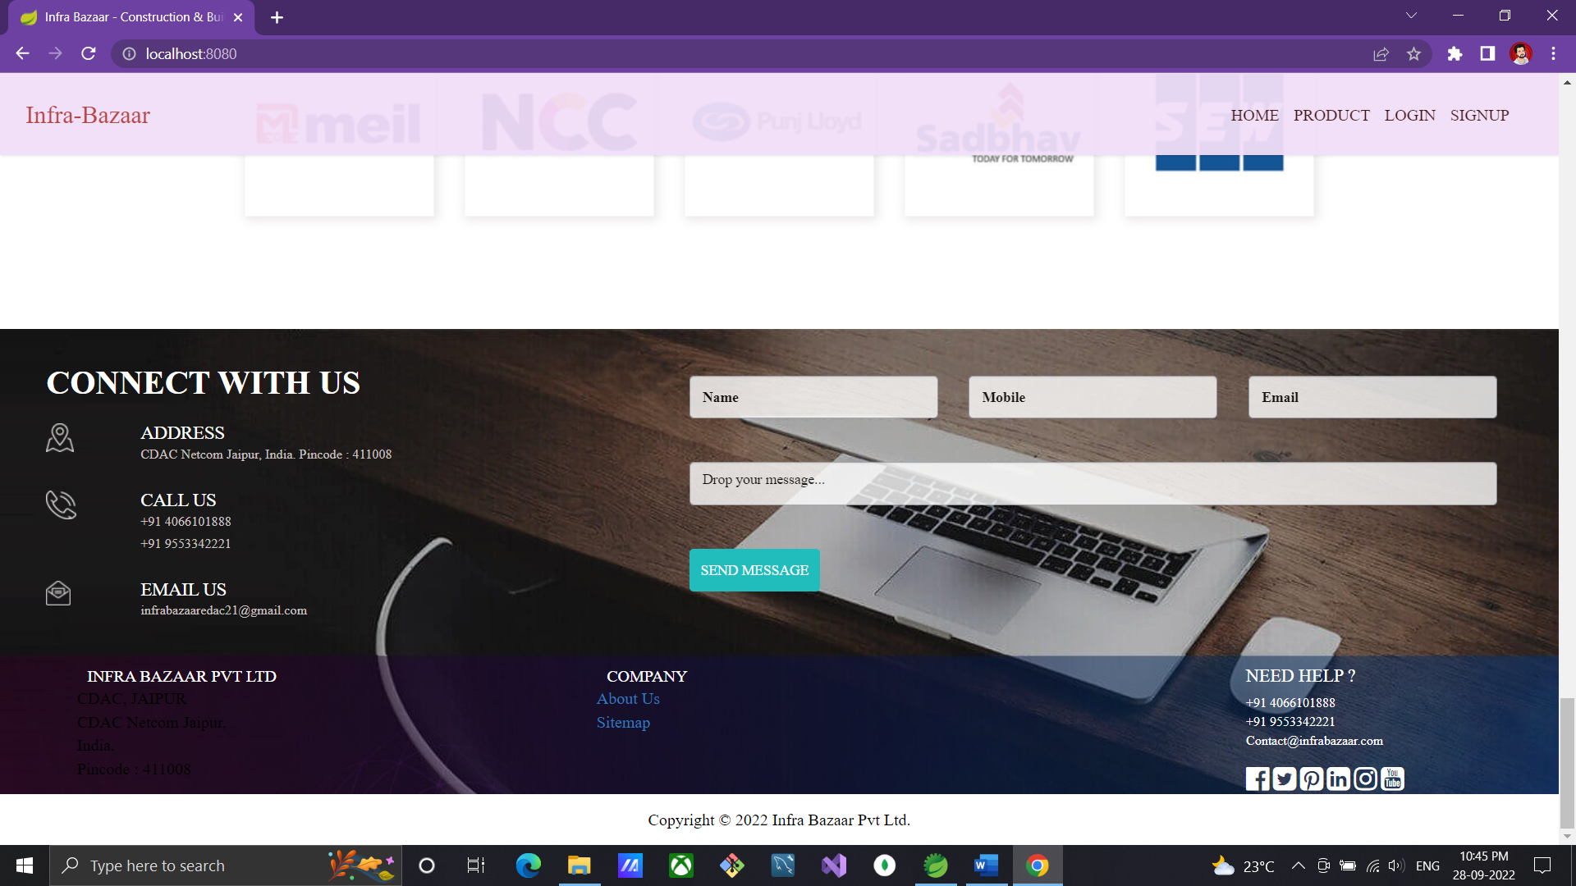

## Registration Page:

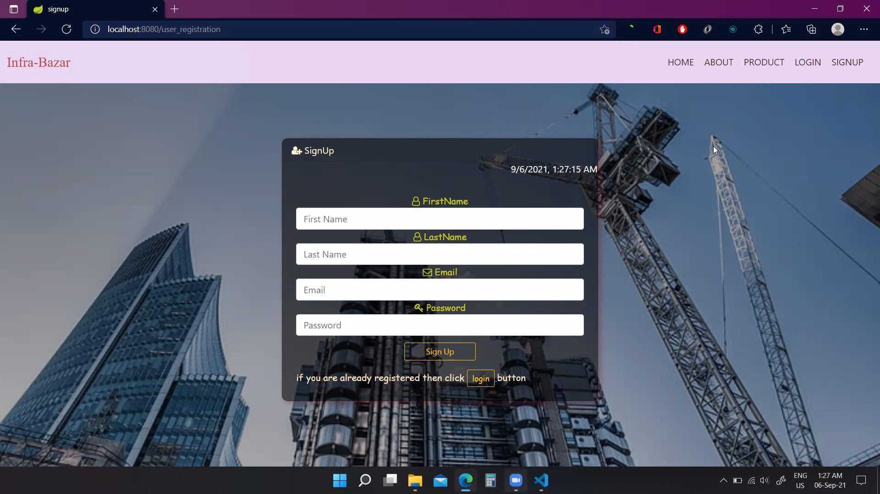

* + **Login Page:**

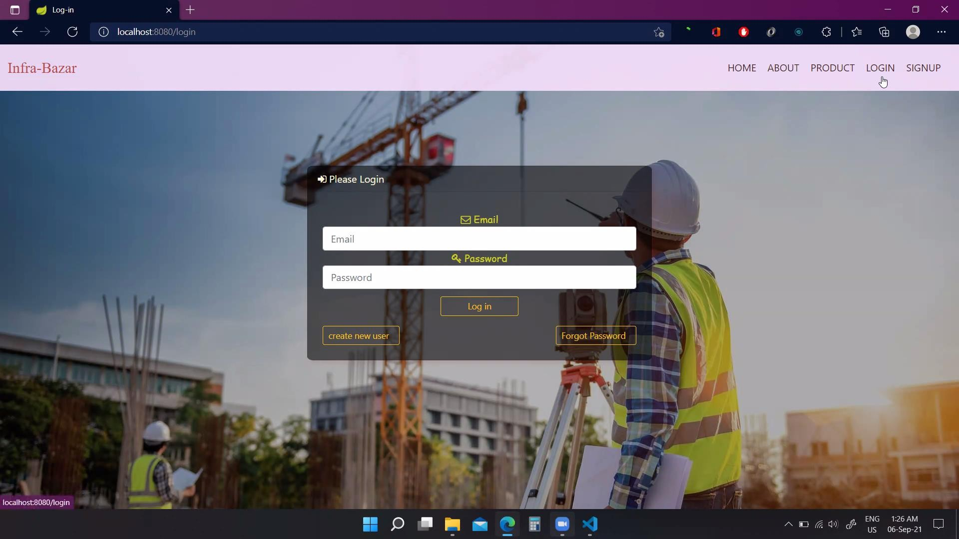

## Product Categories:

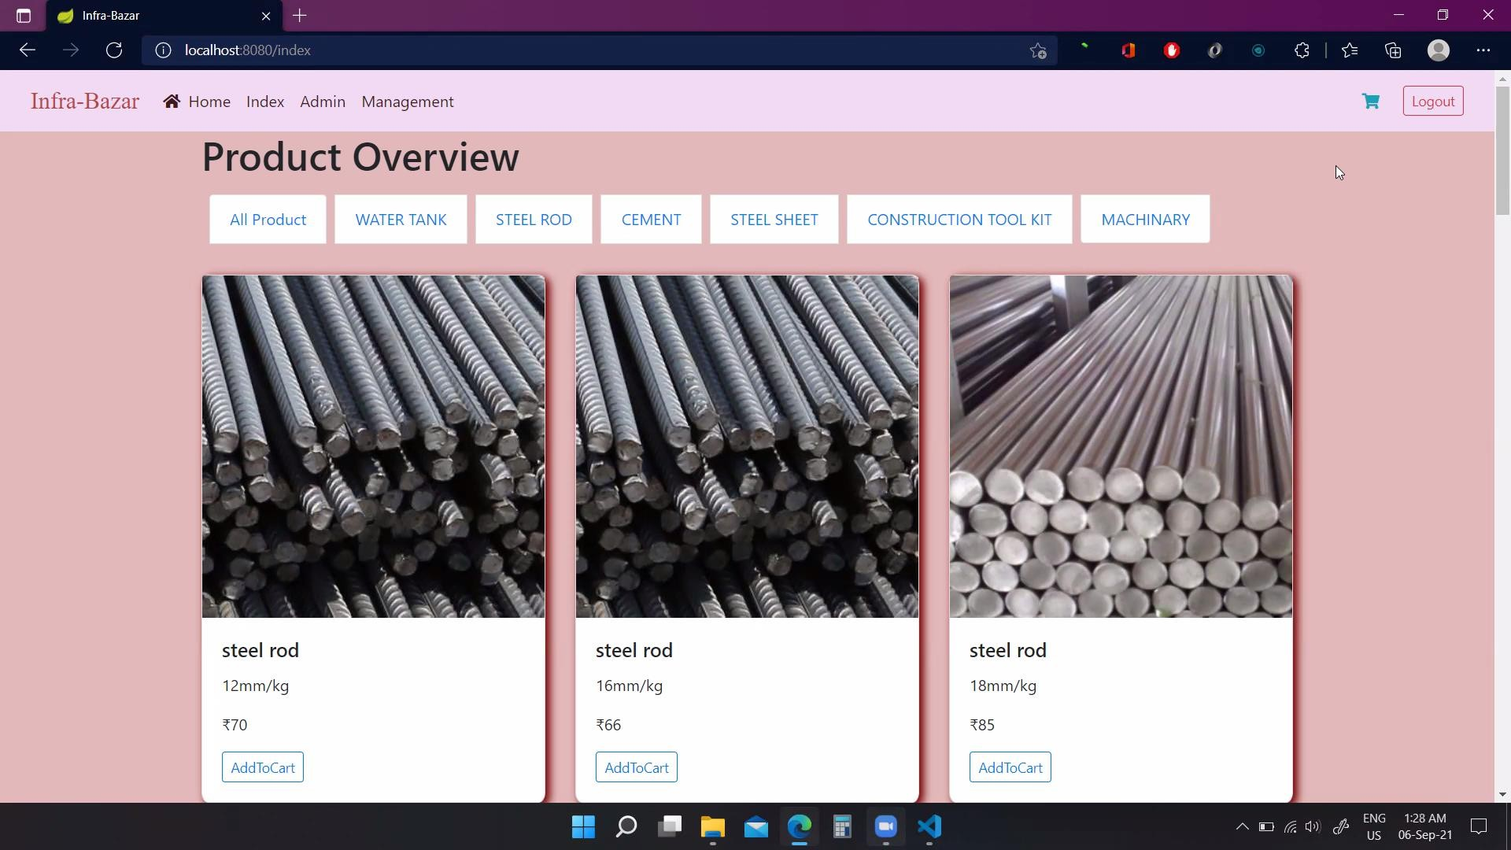

* + **Admin Page:**

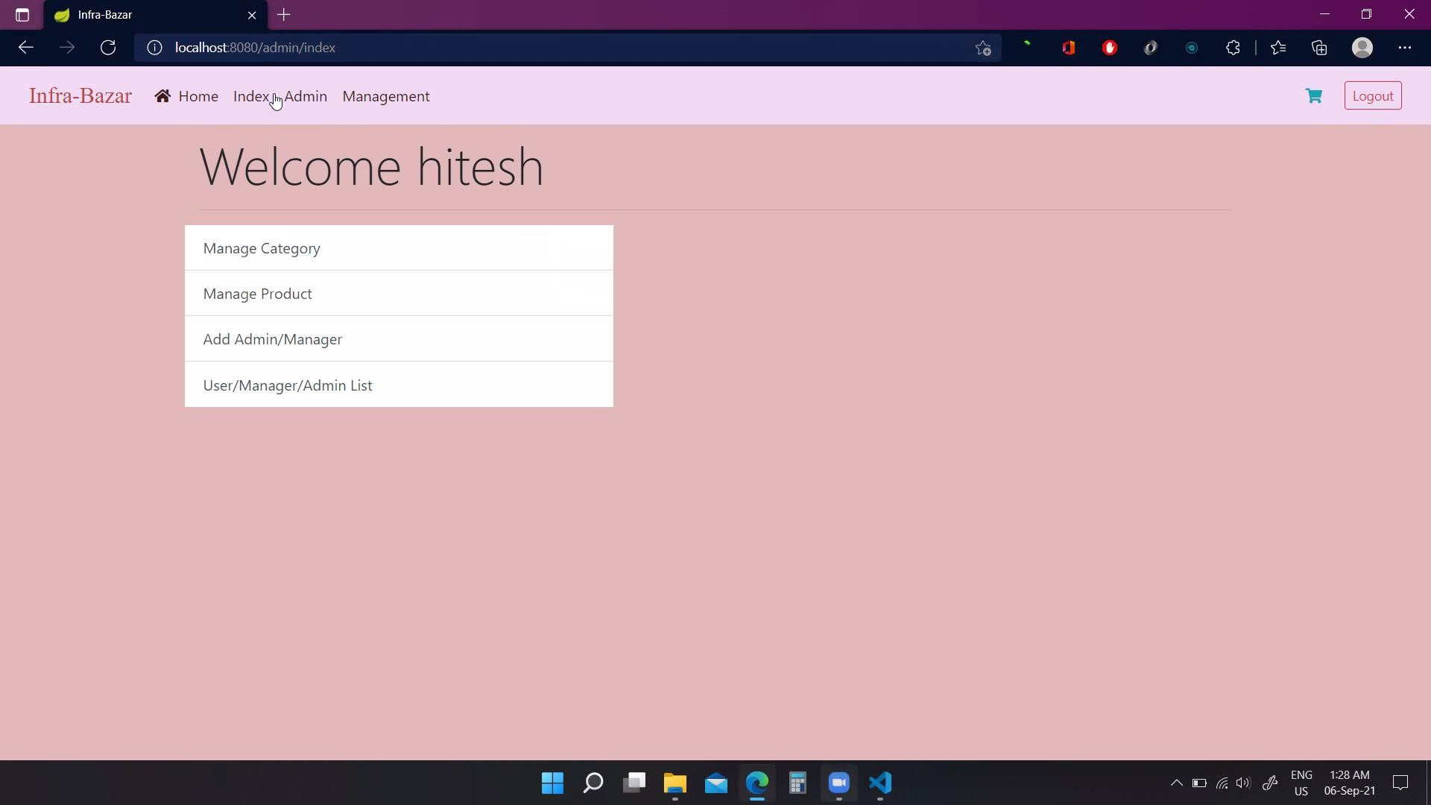

* + **Admin Add User:**

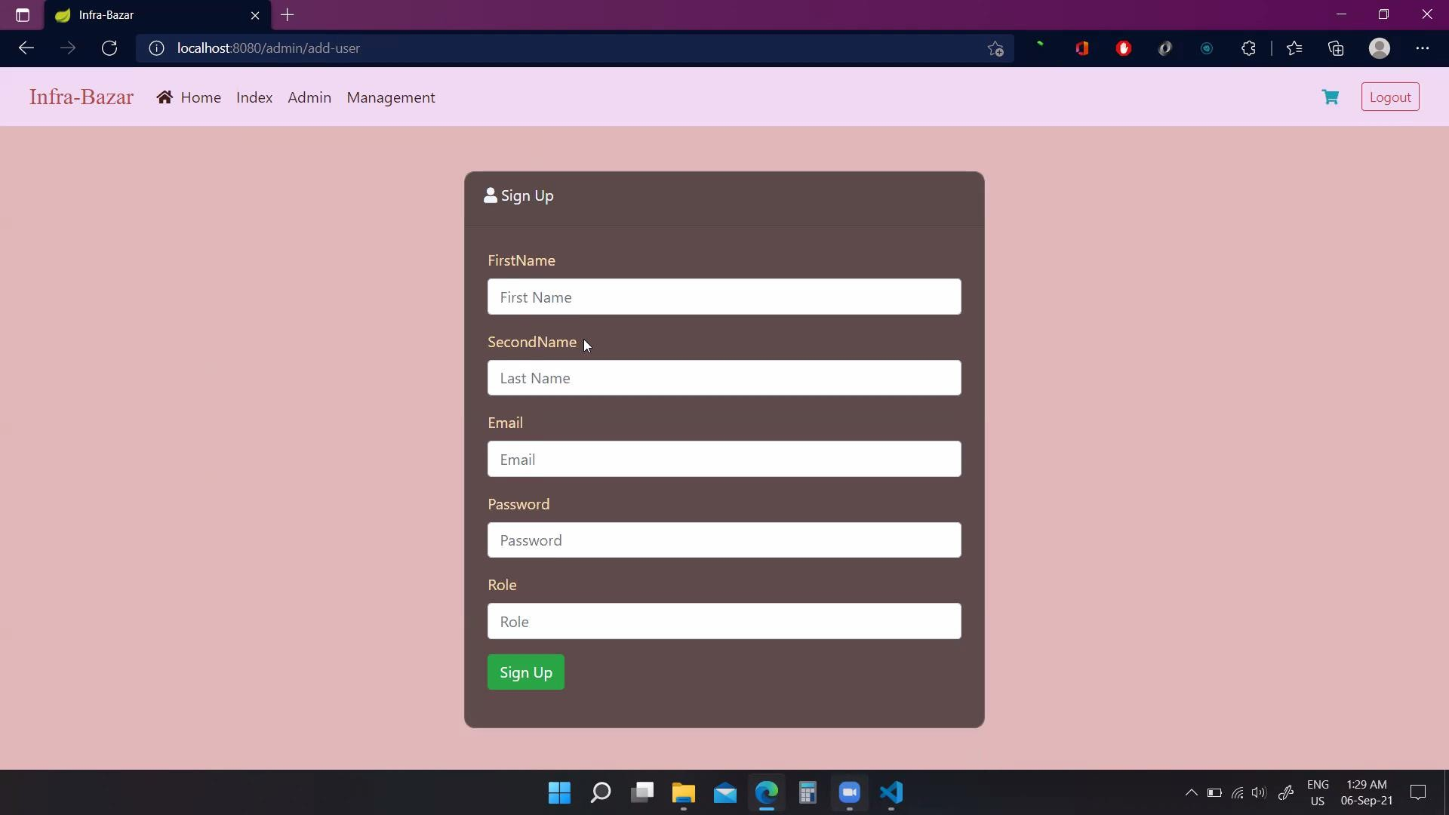

* + **Admin Users List:**

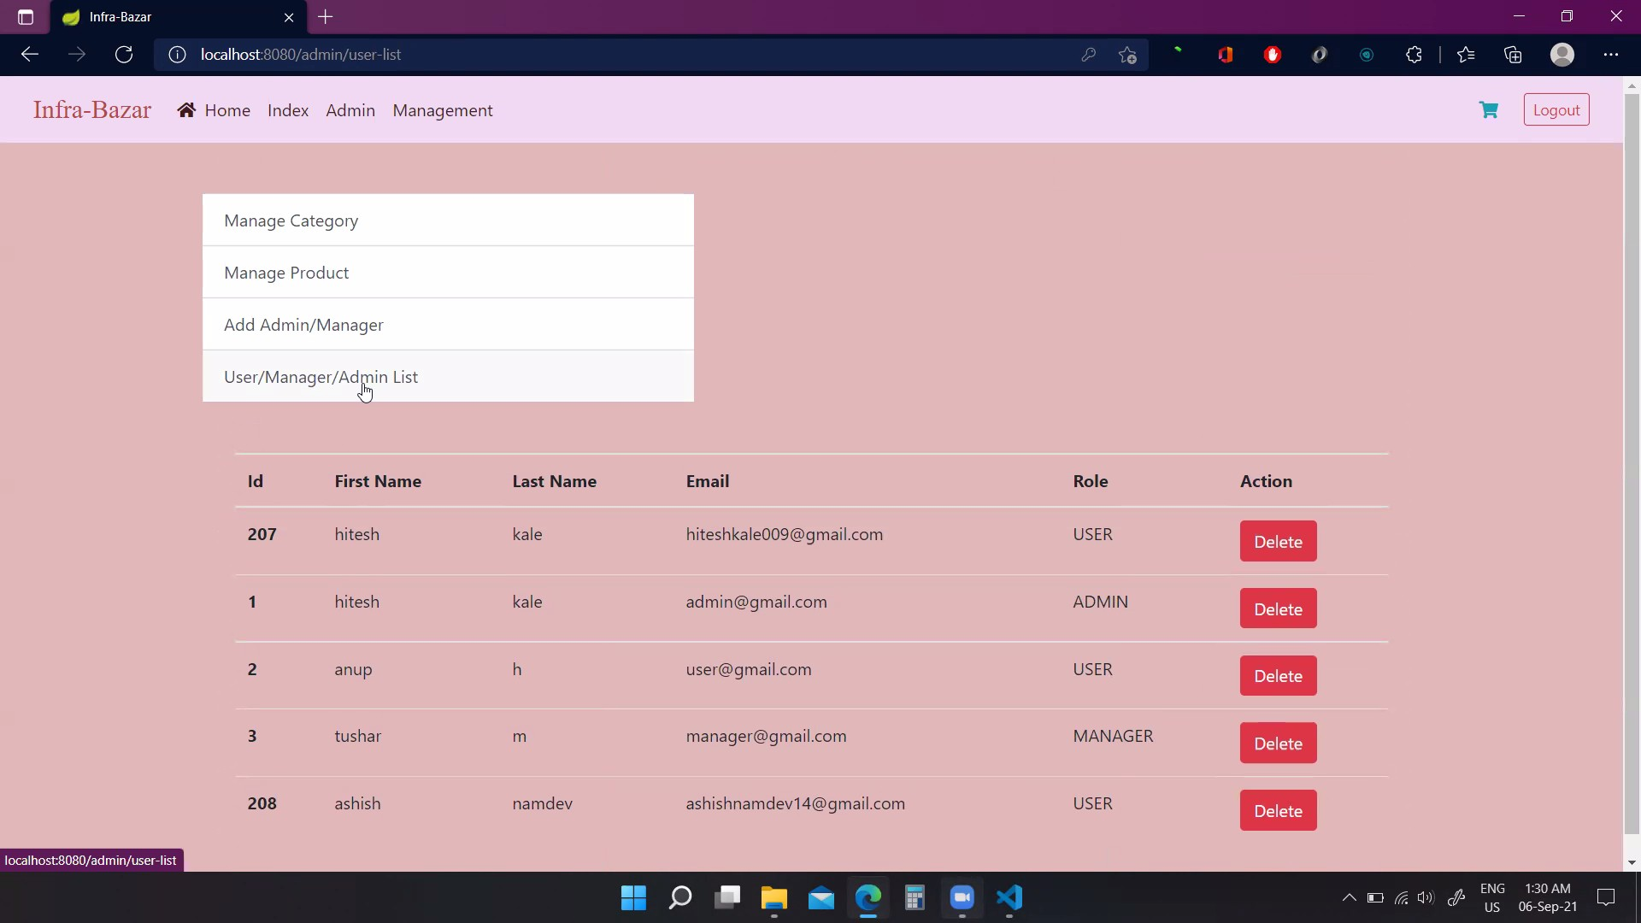

* **Manager Page:**

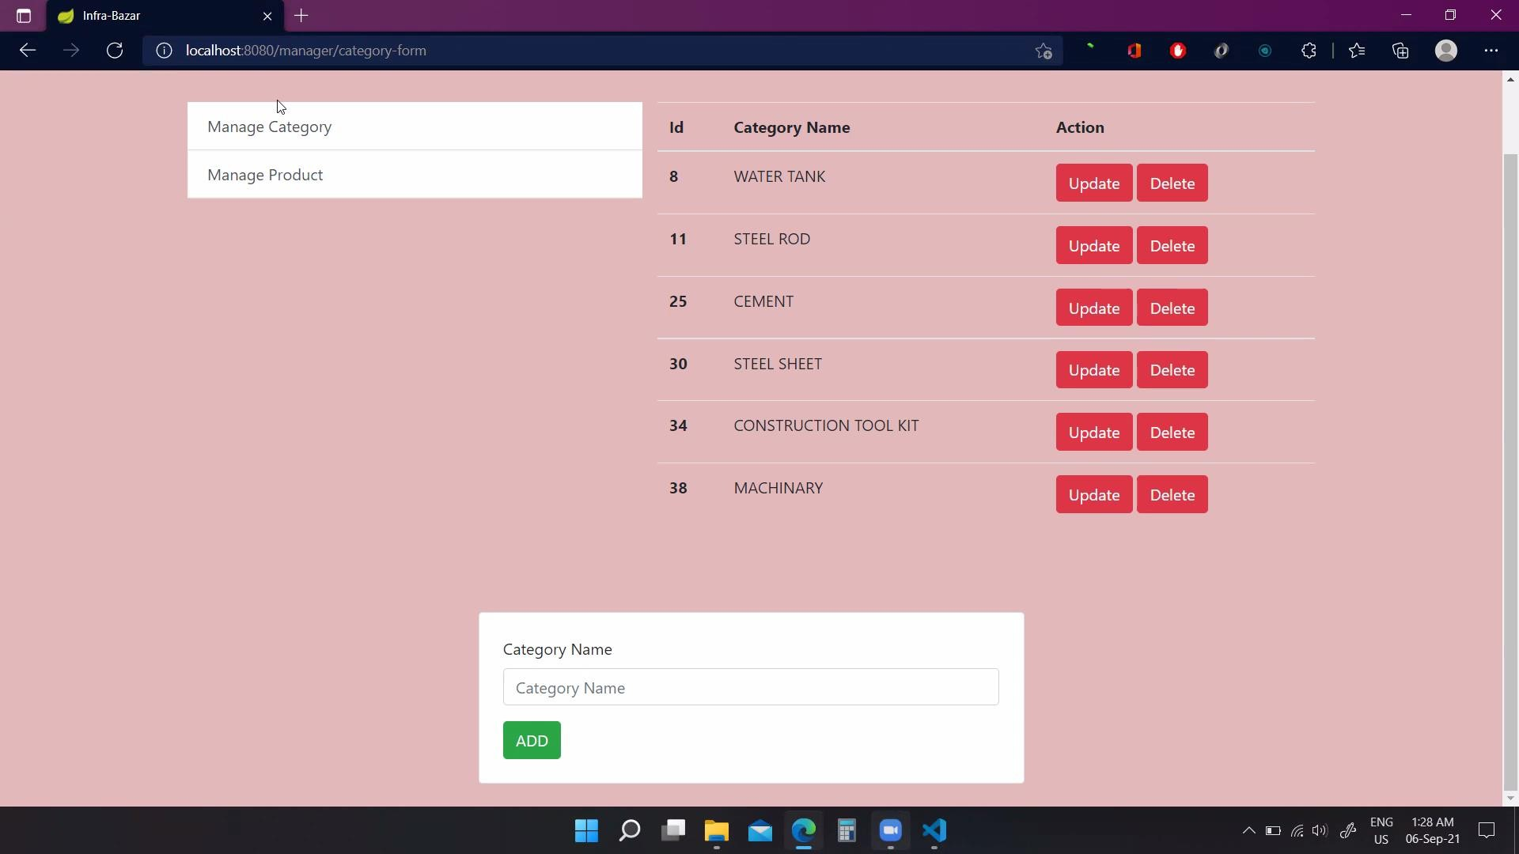

* **Manager Product Add, Update, Delete Page:**

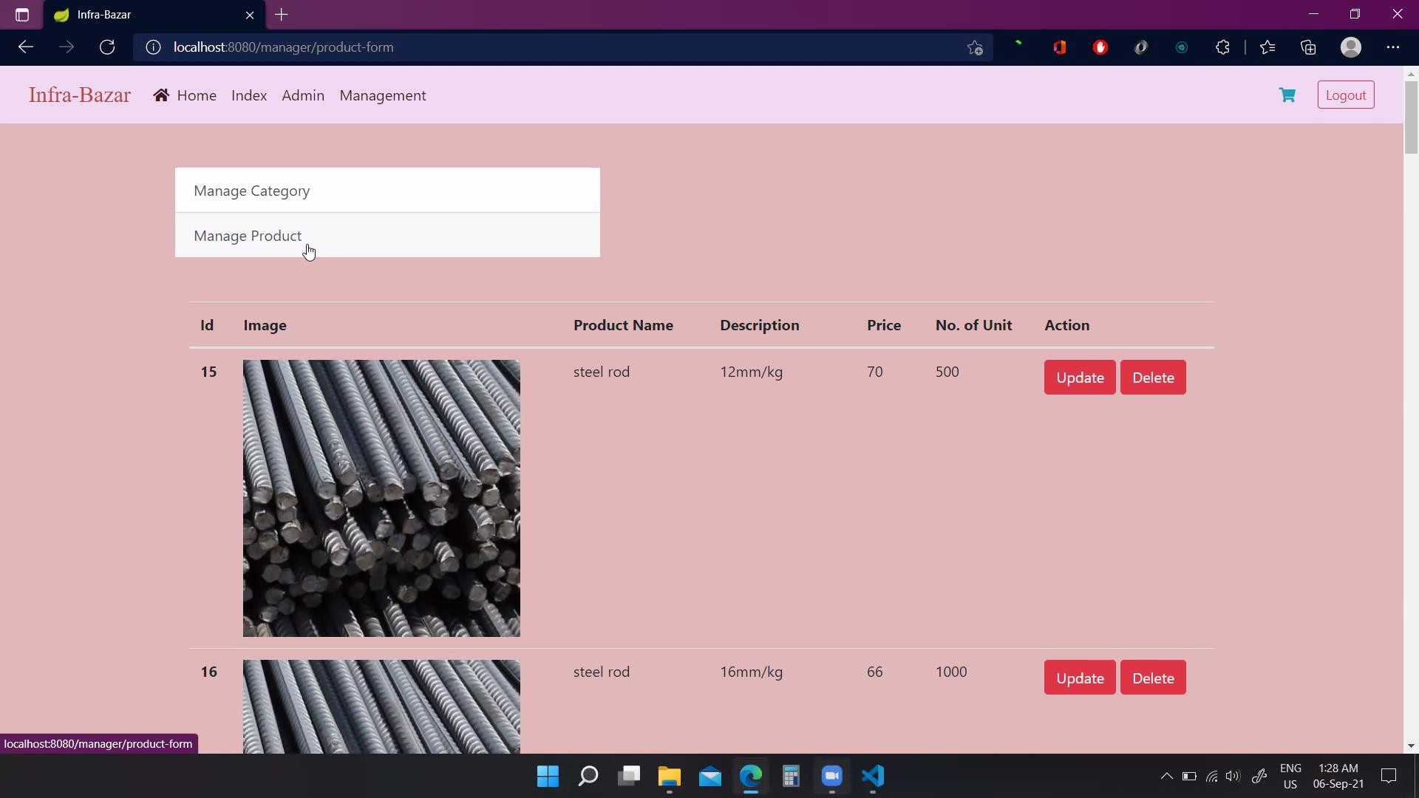

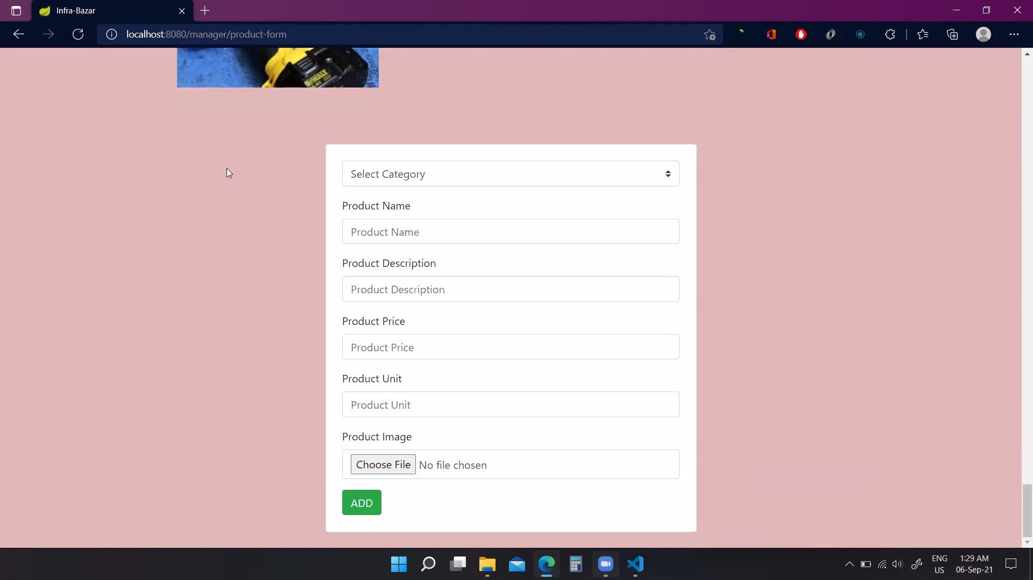

* **Customer Product Cart:**

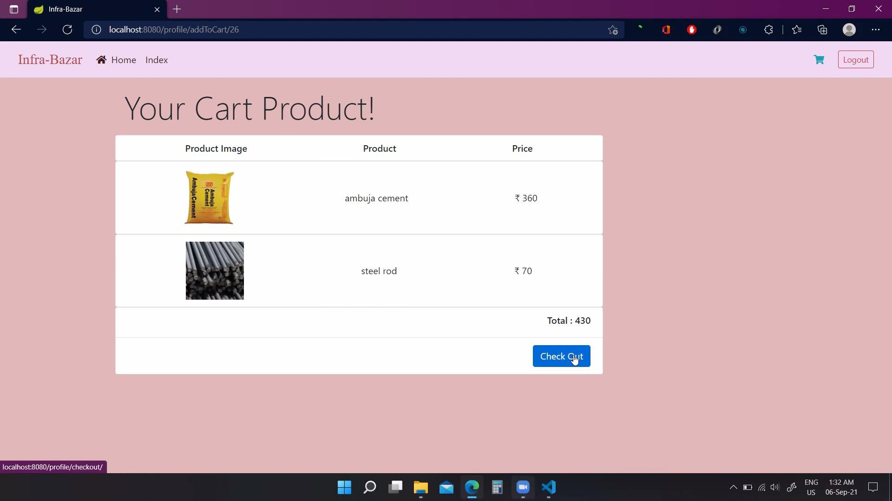

* **Order Details Page:**

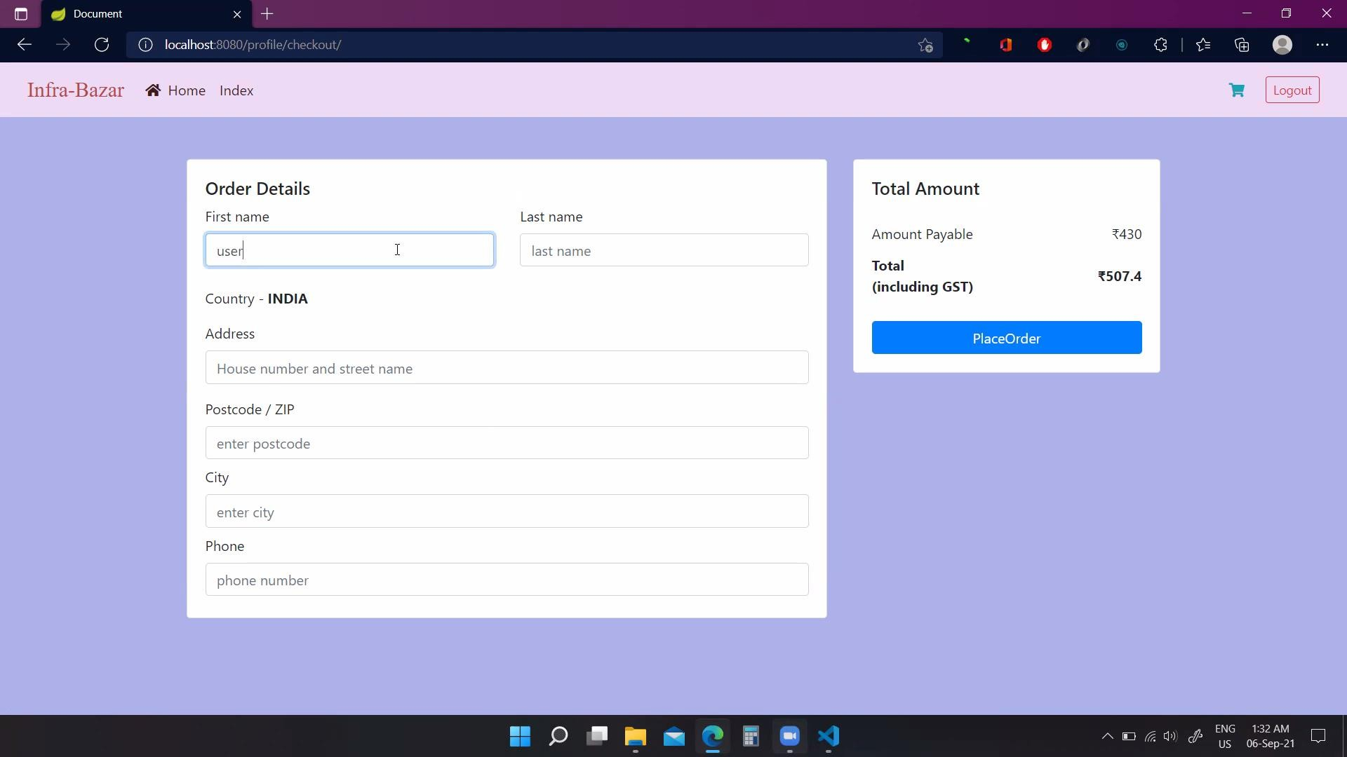

* **Payment Gateway:**

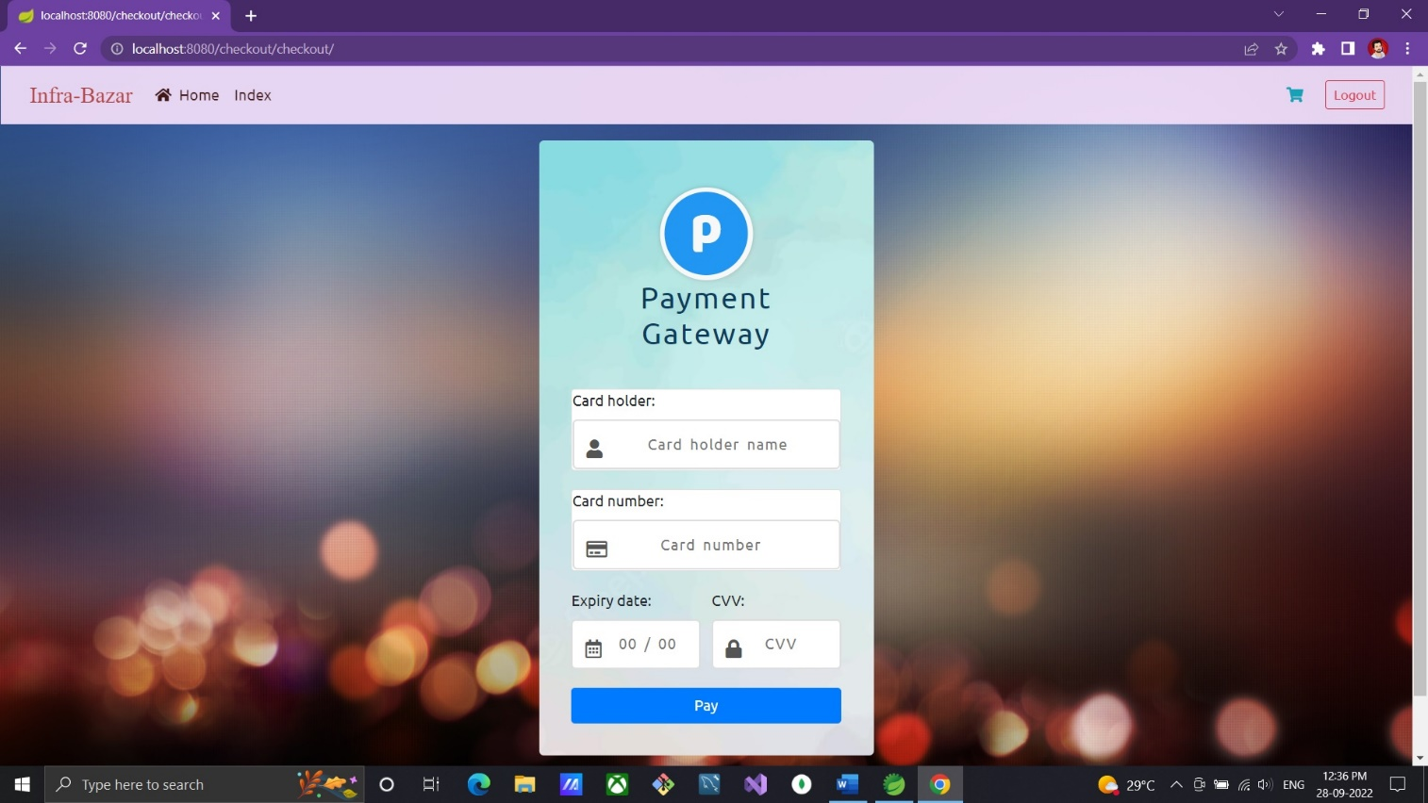

* **Order Confirmation:**

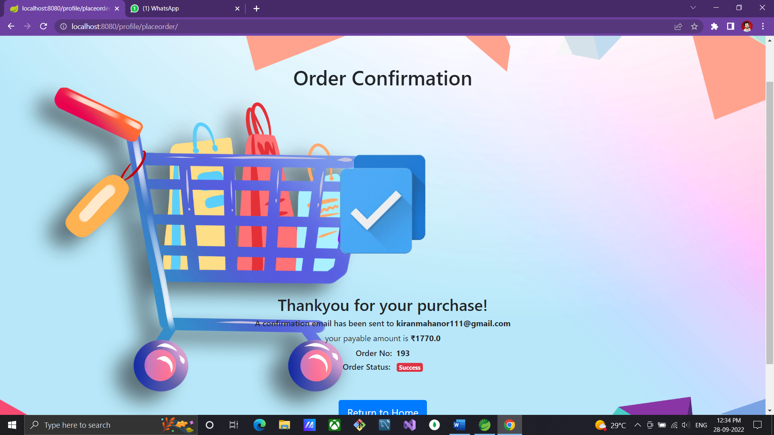

* **Payment and Order Confirmation Mail:**

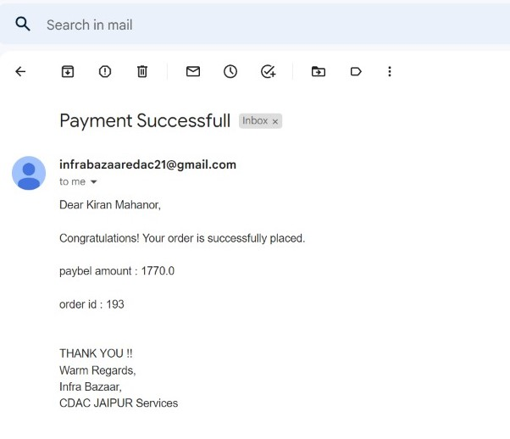

* **Forget Password Page:**

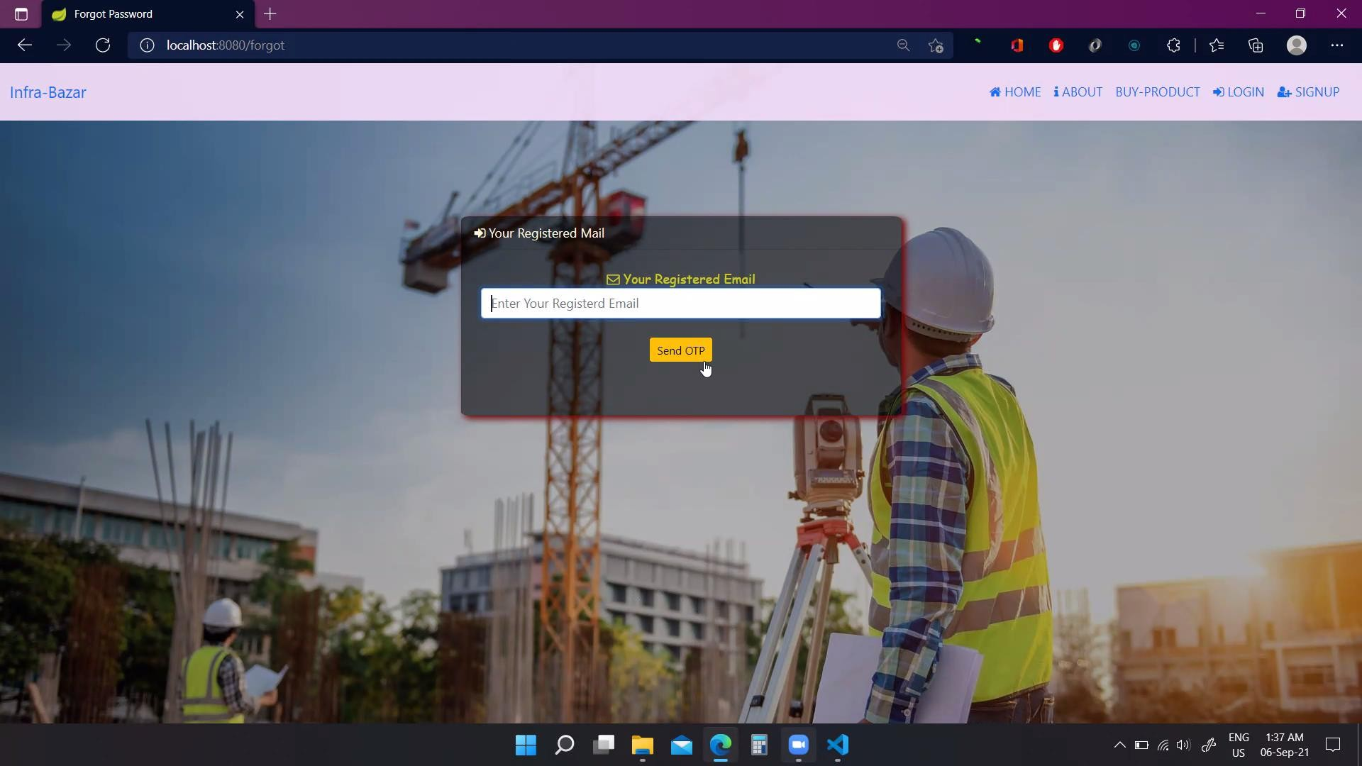

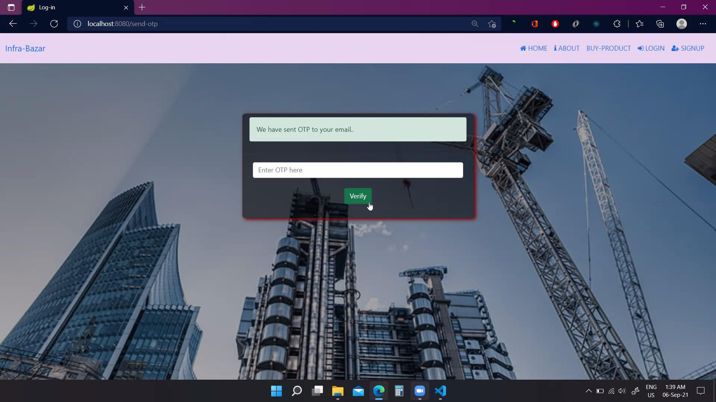

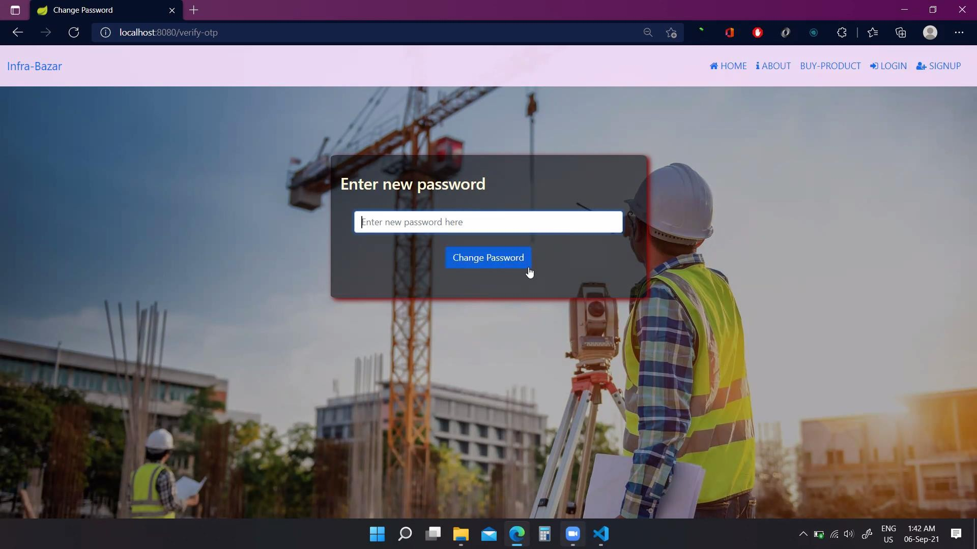

* **Server End Validation (for Existing Users):**

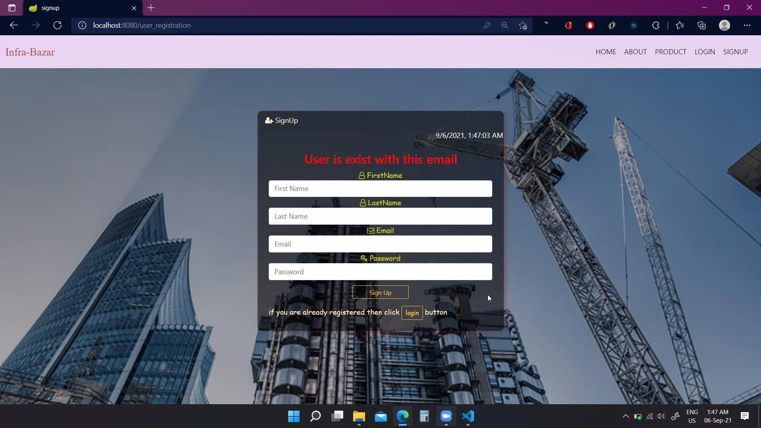

**CONCLUSION**

The existence of electronic commerce has changed the ways and manners we conduct business and carryout transactions. Globalization of ecommerce is widely embraced by both organizations and consumers; our marketplace is more efficient, reliable and more accountable than the way it use to be before the exiting of electronic commerce. The world is coming to be one marketplace by building a strong network opportunity with the use of electronic commerce.

Electronic commerce is the only online activities drive and crease efficient economy around the world, is free market systems who has free entry and exit everyone at the marketplace have equal right to the product and services with electronic commerce. In this model world, the economy depends on business and business depends on consumer to drive the goods and services and move the economy forward.

Electronic commerce enhances and promotes business to business transactions include consumer to consumer relations for greater services and organizations productivity.

## Appendix

Appendix I

* GUI: Graphical User Interface
* Platform dependent operating system which should be compatible with our software.
* SQL: Structured Query Language
* HTML: Hyper Text Markup Language
* CSS: Cascading Style Sheet

## Acknowledgements

Presentation inspiration and motivation have always played a key role in the success of any venture.

We express our sincere thanks to Dr. C. P. Johnson, Senior Director, Center for Development of Advance Computing (C-DAC), Mumbai.

We pay our deep sense of gratitude to Mrs. Suchita Bohra, Course Co-Ordinator, C-DAC NETCOM JAIPUR to encourage us to the highest peak and to provide us the opportunity to prepare the project. We are immensely obliged to our colleague for their elevating inspiration, encouraging guidance and kind supervision in the completion of our project.

We feel to acknowledge our indebtedness and deep sense of gratitude to our guide Ms. Prajakta Patil valuable guidance and kind supervision given to us.

### THANK YOU.